1. Is your browser running HTTP version 1.0 or 1.1? What version of HTTP is the server running?
   1. My browser is running HTTP version 1.1
   2. 
   3. The server is running 1.1
   4. 
2. What languages (if any) does your browser indicate that it can accept to the server?
   1. 
3. What is the IP address of your computer? Of the gaia.cs.umass.edu server?
   1. My PC’s IP is 192.168.252.208
   2. The server is 128.119.245.12
   3. 
4. What is the status code returned from the server to your browser?
   1. Code 200 OK
   2. 
5. When was the HTML file that you are retrieving last modified at the server?
   1. 
6. How many bytes of content are being returned to your browser?
   1. 
7. By inspecting the raw data in the packet content window, do you see any headers within the data that are not displayed in the packet-listing window? If so, name one.
   1. I don’t think so. It looks like all the data is displayed in the window.
8. Inspect the contents of the first HTTP GET request from your browser to the server. Do you see an “IFMODIFIED-SINCE” line in the HTTP GET?
   1. No, I don’t see a “IFMODIFIED-SINCE”
   2. 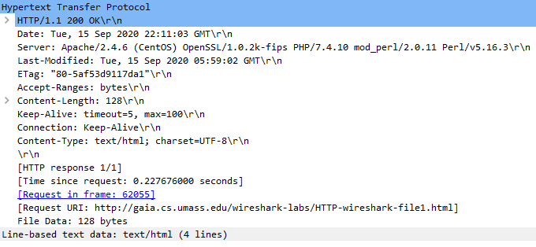
9. Inspect the contents of the server response. Did the server explicitly return the contents of the file? How can you tell?
   1. Yes, the server did return the exact file contents.
   2. 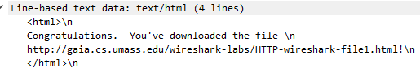
10. Now inspect the contents of the second HTTP GET request from your browser to the server. Do you see an “IF-MODIFIED-SINCE:” line in the HTTP GET? If so, what information follows the “IF-MODIFIEDSINCE:” header?
    1. No, there wasn’t any.
    2. 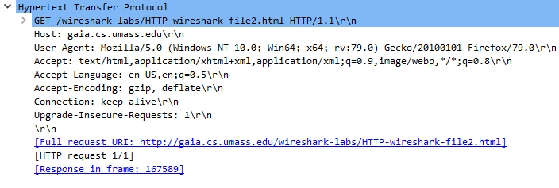
11. What is the HTTP status code and phrase returned from the server in response to this second HTTP GET? Did the server explicitly return the contents of the file? Explain.
    1. It returned code 200 OK which I do not think it should because it didn’t return the file contents.
    2. 
12. How many HTTP GET request messages did your browser send? Which packet number in the trace contains the GET message for the Bill or Rights?
    1. The browser only sent one request. Packet # 198609
    2. 
13. Which packet number in the trace contains the status code and phrase associated with the response to the HTTP GET request?
    1. Packet # 198639
    2. 
14. What is the status code and phrase in the response?
    1. The code returned is 200 OK
    2. 
15. How many data-containing TCP segments were needed to carry the single HTTP response and the text of the Bill of Rights?
    1. It looks like 3 segments
    2. 
16. How many HTTP GET request messages did your browser send? To which Internet addresses were these GET requests sent?
    1. 3 GET requests from 128.119.245.12
    2. 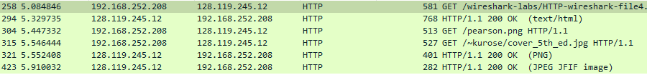
17. Can you tell whether your browser downloaded the two images serially, or whether they were downloaded from the two web sites in parallel? Explain.
    1. They were downloaded serially because the first image returns and then a status code is sent before another is returned.
18. What is the server’s response (status code and phrase) in response to the initial HTTP GET message from your browser?
    1. It is a 401 Unauthorized code
    2. 
19. When your browser’s sends the HTTP GET message for the second time, what new field is included in the HTTP GET message?
    1. It has an Authorization field, which has the username and password in plane text
    2. 